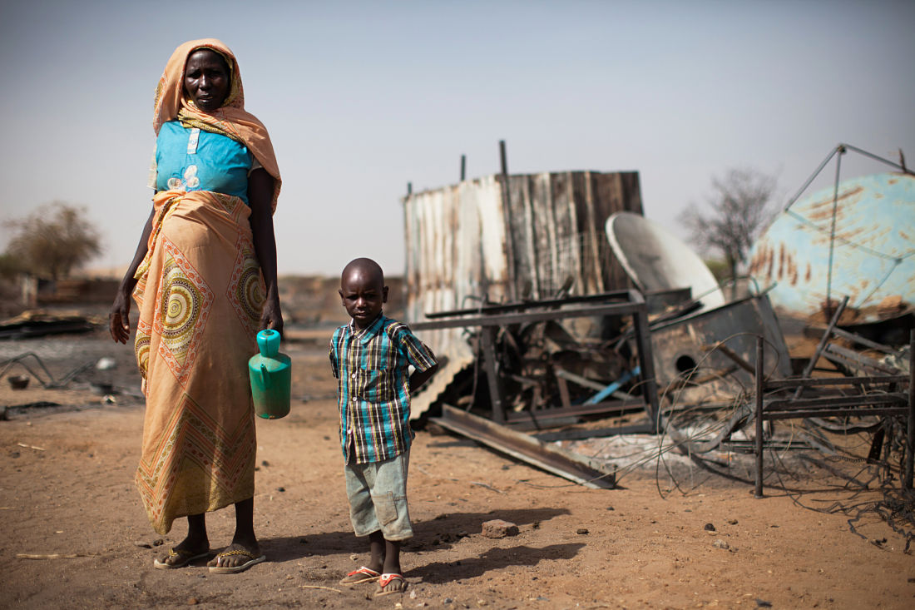
Year 10 Geography Unit 3 Overview – Resource Management
AQA GCSE Geography Paper 2- Challenges in the Human Environment

You will learn about:
- Distribution of resources globally and in the UK
- Provision of food, energy and water
- Impact of water insecurity
- Methods to increase water supply
You will be able to:
- Use case studies/examples to explain processes.
- Carry out research.
- Use and create graphs/diagrams/maps to describe information.
- Use literacy (PEEL and PEAL).

Lesson Overview:  - Global resource inequalities and importance of resources for humans.  - The changing demand and provision of food and energy resources in the UK.  - The rising demand for water globally and impacts of water insecurity.  - Changing demand and provision of water resources in the UK.  - Case study of a large-scale water management scheme – South to North Transfer Project, China  - Sustainable, small scale water management– Artificial glaciers in Ladakh, India  - Revision/Consolidation  - End of Unit Assessment |  |  | Key Words:  Aquifer- under  Carbon footprint – emission of carbon dioxide into the atmosphere  Dam – controls the flow of rivers and creates a reservoir to store water behind it  Desalination – removing salt from seawater to produce freshwater  Energy Mix – the range (differences) and proportions (amount of) of different energy sources  Food deficit – countries do not produce enough food to feed their population and have to rely on imported food  Food insecurity – where demand (the need for food) exceeds (is more than) the supply (amount of food)  Food miles – the distances travelled by foods imported to the UK  Food surplus – countries that produce more food than is needed by their population  Fracking – extraction of natural gas using high-pressure liquids e.g. water, sand and chemicals to fracture shale rock and release gas  Organic produce – food/crops are grown without the use of chemicals  Over-abstraction – pumping water out of the ground e.g. aquifers faster than it can be replaced/replenished  Resource – a stock or supply of something that has value or purpose  Undernutrition – (malnutrition) – a lack of a balanced diet and deficiency in minerals and vitamins  Water deficit – where demand (the need and use of water) exceeds (is more than) the supply (amount of water)  Water stress – where demand (the need and use of water) exceeds (is more than) the supply (amount of water)  Water surplus – where the supply (amount of) water exceeds (is more than) the demand  Water transfer – moving water from areas of surplus to areas in deficit to meet demand.
Suggested reading:  The Water Book by Alok Jha  Non-fiction articles available on showbie |  |  | Cross curricular:  - SMSC: develop a critical understanding of how we use resources and how different areas around the World are impacted by the availability and use of their resources differently  - Literacy: using key geographical terms, PEAL to write well balanced explanations and comparisons. Accurate SPAG.  - Numeracy: to analyse trends in data, reading and drawing pie charts, bar graphs.
Research | Note-making | Group work & discussion |  | Memorisation | Precision & accuracy | Independence | Reflection

